***This file provides the manual for the game TIC TAC TOE***

* ***After clicking on your choice this window will pop up:***

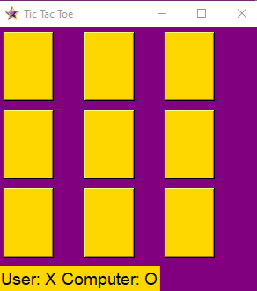

* ***By clicking on the buttons you can position your symbol***
* ***Immediately after the click the computer will also display it’s choice of position.***
* ***After one round the results are announced.***